A Synopsis
on
“SHORTEST PATH FINDING VISUALIZER”
Submitted to the
Savitribai Phule Pune University
In partial fulfilment for the award of the Degree of
Bachelor of Engineering
in
Computer Engineering
by
Sushant Mahadwad 60
Satyam Dighe 12
Kunal Suryawanshi 59
Deepak Rai 45

Under the guidance of
Prof. Prachi Nilekar



DEPARTMENT OF COMPUTER ENGINEERING
ALARD COLLEGE OF ENGINEERING
(Survey No. 50, Marunje, Near Rajiv Gandhi IT Park, Pune, 411057)

AFFILIATED TO
SAVITRIBAI PHULE PUNE UNIVERSITY
2022-2023

CONTENT

Sr. No. | Topic | Page No.
 | Acknowledgement | I
 | Abstract | II
Chapter 1 | Project Overview / Background
1 | Introduction | 1
2 | Motivation | 2
3 | Scope of the Project | 3
4 | Problem Statement | 4
5 | Methodology | 5
6 | Block Diagram | 6
Chapter 2 | Project Requirements
1 | Software and Hardware Requirement | 7
Chapter 3 | Applications | 8
Chapter 4 | Conclusion | 9
Chapter 5 | References | 10

ACKNOWLEDGEMENT

However we put a lot of time and effort into this task. And many individuals have helped and assisted us in completing this task. We would like to express our sincere gratitude to everyone and thank Prof. Prachi Nilekar for her role as our guide and for always being there by keeping an eye on us and providing her necessary input and information on the project.

We would also like to thank HOD Prof. Priyadarshini Doke from the Computer Engineering Department for her moral support and motivation in helping us to make this project a reality. And Thankful to Principal Dr. Sanjay Talbar who gave us his constant support and motivation which was very helpful in bringing our project to life.

We would like to take this opportunity to thank our teachers, friends and everyone who contributed to the completion of our project.

Sushant Mahadwad
Satyam Dighe
Kunal Suryawanshi
Deepak Rai
(B.E. Computer Engg.)

I

ABSTRACT

Visualization is an efficient way to learn concepts faster than traditional methods. Modern technology enables the creation of e-learning tools, which also greatly contribute to the improvement of computer science education. The goal of this project is to create the Pathfinding Visualizer, a web-based e-learning tool that can be used to visualize the Shortest Path algorithm. Conceptual applications of the project are illustrated through implementations of algorithms such as Dijkstra’s and DFS. This project aims to perform all these tasks with some knowledge of HTML, CSS, JavaScript, and the React framework. Since the final product is a web application, users can easily see and learn how the algorithm works. The ease of use of the project provides users with simple operating instructions. First results using the application promise benefits of this here learning tool for students with a good understanding of the shortest path algorithm.

II
PROJECT OVERVIEW

- INTRODUCTION

Currently, e-learning is being promoted very strongly among from different fields. Modern technologies enable the development of visualization tools for topics such as various graph theory algorithms and their descriptions. The implementation of such e-learning tools is one of the most important prerequisites for the successful use of any e-learning system. Learning by visualization has been shown to help improve learning ability. Gives more autonomy to an individual’s learning process. By providing a visual representation of what the destination node algorithms look like, applications aim to make them easier to understand. A good algorithm visualization tool will bring the algorithm to life by showing the traversal of nodes through the and animating transitions from one node to another. One of the broader applications of graph theory is the determination of shortest paths in many practical applications such as maps, road networks, and robot navigation. Dijkstra’s algorithm is used to demonstrate how the tool works. This is because it also works for weighted graphs. So, it takes longer to run than BFS.

- MOTIVATION

Now a days e-learning is spreading widely. And students are grabbing the concept to fast. So, we decided to contribute to e-learning. As we are aware of algorithms, we find it difficult to learn. And most of the students don’t understand and leave it without completing it. we have also gone through these stages of leaning algorithms and found it difficult.

Visualization is the best way to learn any difficult thing as per studies it is found that most part of can be grabbed from visualization The motivation behind this project is to investigate how operations on data structures are performed. Enable students to learn various algorithms through animation. Gain a clear knowledge of various data structures and operations on them. Makes learning data structures more interesting. The main goal of this project is to implement various sorting algorithms, prime number and binary search game systems. - Investigate and visualize the best and worst cases for each algorithm rule implemented.

- SCOPE OF PROJECT

- A recent study made by the World Economic Forum showed that after the United States, India has the largest number of online course enrolments with more than 2,00,000 students. Reputed universities offer top-notch certified online courses, bringing world-class professors and instructors to impart learning to the students.

- Now a days every student is moving towards E-learning. As it makes study easier. And in that studies found that visualization makes you understand any complicated thing earlier.

- PROBLEM STATEMENT

In recent years, we have seen huge growth in computer science education. There are many difficult topics in computer science, that are very complex to learn unique algorithms like shortest path algorithms, these are often hard and complex to understand. Modern technologies have proven to be a boon for learning process. Visual aids have been recognised as means to amplify learning capabilities of an individual. Visualisation makes understanding the explanation of a particular topic surprisingly easy. We seek to build such an e-learning tool, using which one can learn path finding algorithms through visualisation of every step of working of algorithm.

Features of the tool:

- Easy to use
- Ensure visualization better by adding animation
- Ability to add obstacles in the path

- METHODOLOGY

1.Select an algorithm.

2. Add maze or bomb to the path.

3. Add a start node.

4. Add A destination node.

5. Start the algorithm.

6. It shows you the shortest path to the destination node.

- BLOCK DIAGRAM
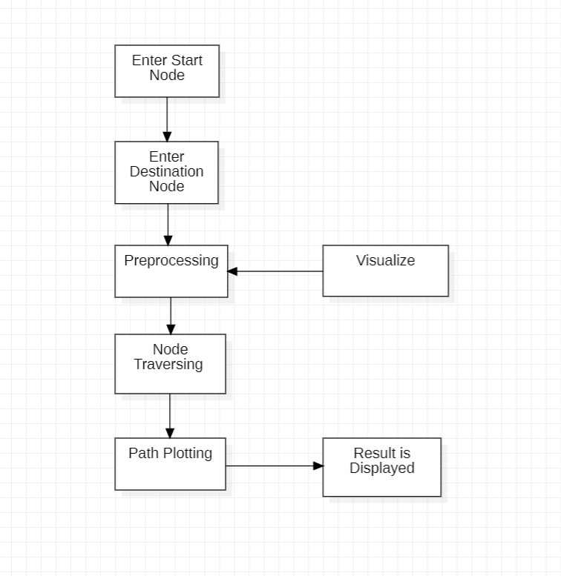

VII. ADVANTAGES

1. E-learning Fully Adjusts to Your Needs

2. Reduced Cost

3. Remote Approach To Various Classes

4. Transfer Credits & Commuting

5. Instant Career Advancement

6. Quick Delivery

7. Scalability

8. Consistency & Teacher Scarcity

9. E-learning Offers Personalization

10. E-learning Fully Utilizes Analytics

VIII. CONCLUSION

e-Learning is the latest solution for delivering education and knowledge. A variety of tools have been developed to implement this method of learning and to get people to recognize and accept its importance. Both synchronous and asynchronous learning methods are equally important. ’s e-learning tools meet the needs of ’s novices and experts alike, and its consistency also proves his ’s effectiveness in traditional methods. The web application helped visualize how the pathfinding algorithm works and made it easy to understand. Further development of this tool may involve visualization of more complex algorithms and their implementation on real maps.

IX.REFRENCES

[1] Alexander, S. (2001), “e-Learning developments and experiences”, Education and Training, Vol. 43 Nos 4/5, pp. 240-8 .

[2] Daniela Borissova, Ivan Mustakerov “E-learning Tool for Visualization of Shortest Paths Algorithms.

[3] Magzhan Kairanbay, Hajar Mat Jani(2013), “A review and evaluations of Shortest Path Algorithms ”, International Journal of Scientific Technology Research 2(6):99-104 .

[4] Roles J.A. ElAarag H. (2013). A Smoothest Pathalgorithm and its visualizationtool. Southeastcon, In Proc. of IEEE, DOI: 10.1109/SECON.2013.6567453.

